**Devops:**

New topics:

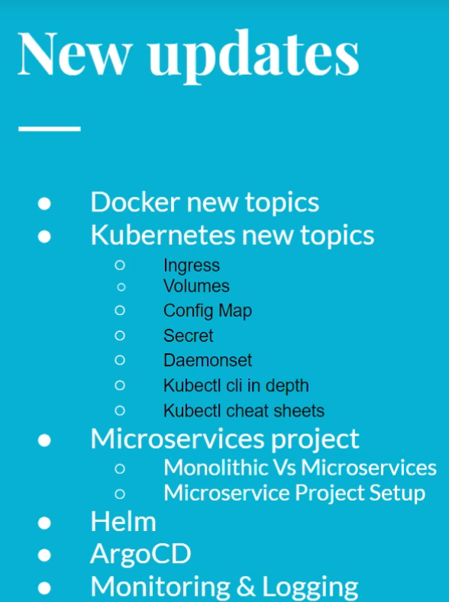

In devops:

The CI lifecycle:

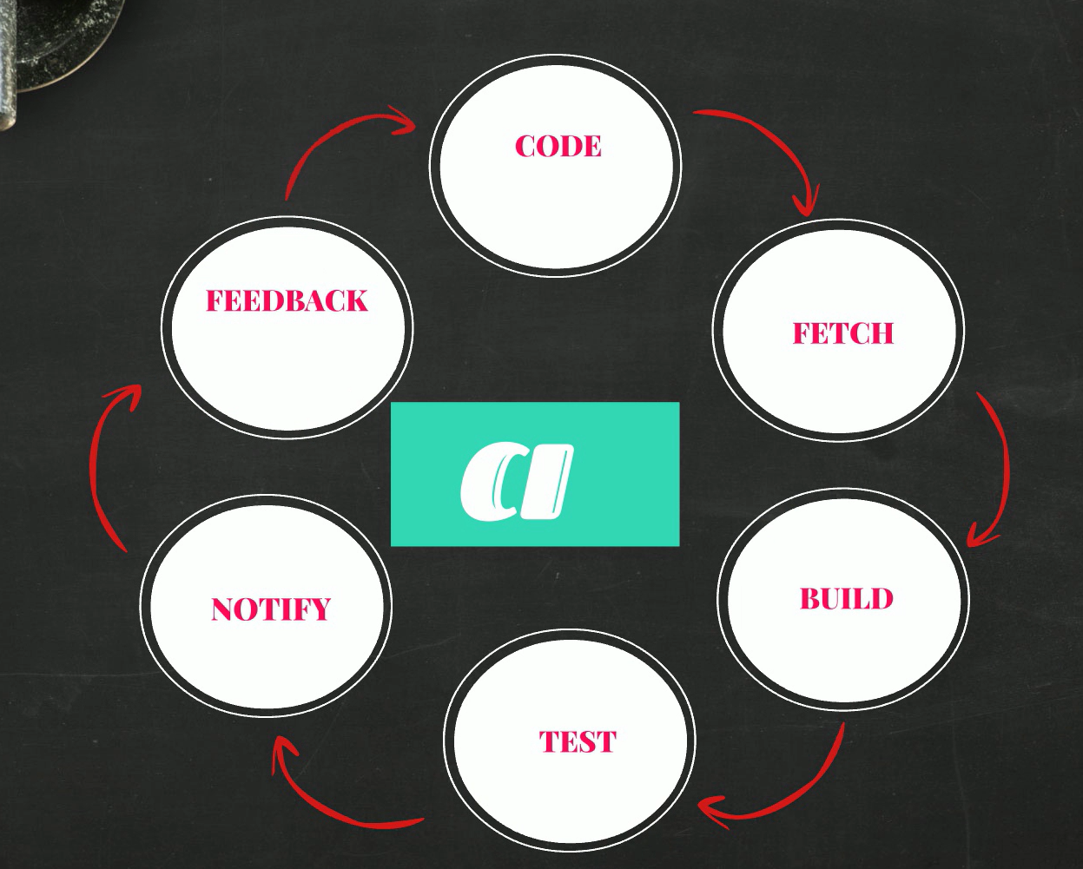

The CD

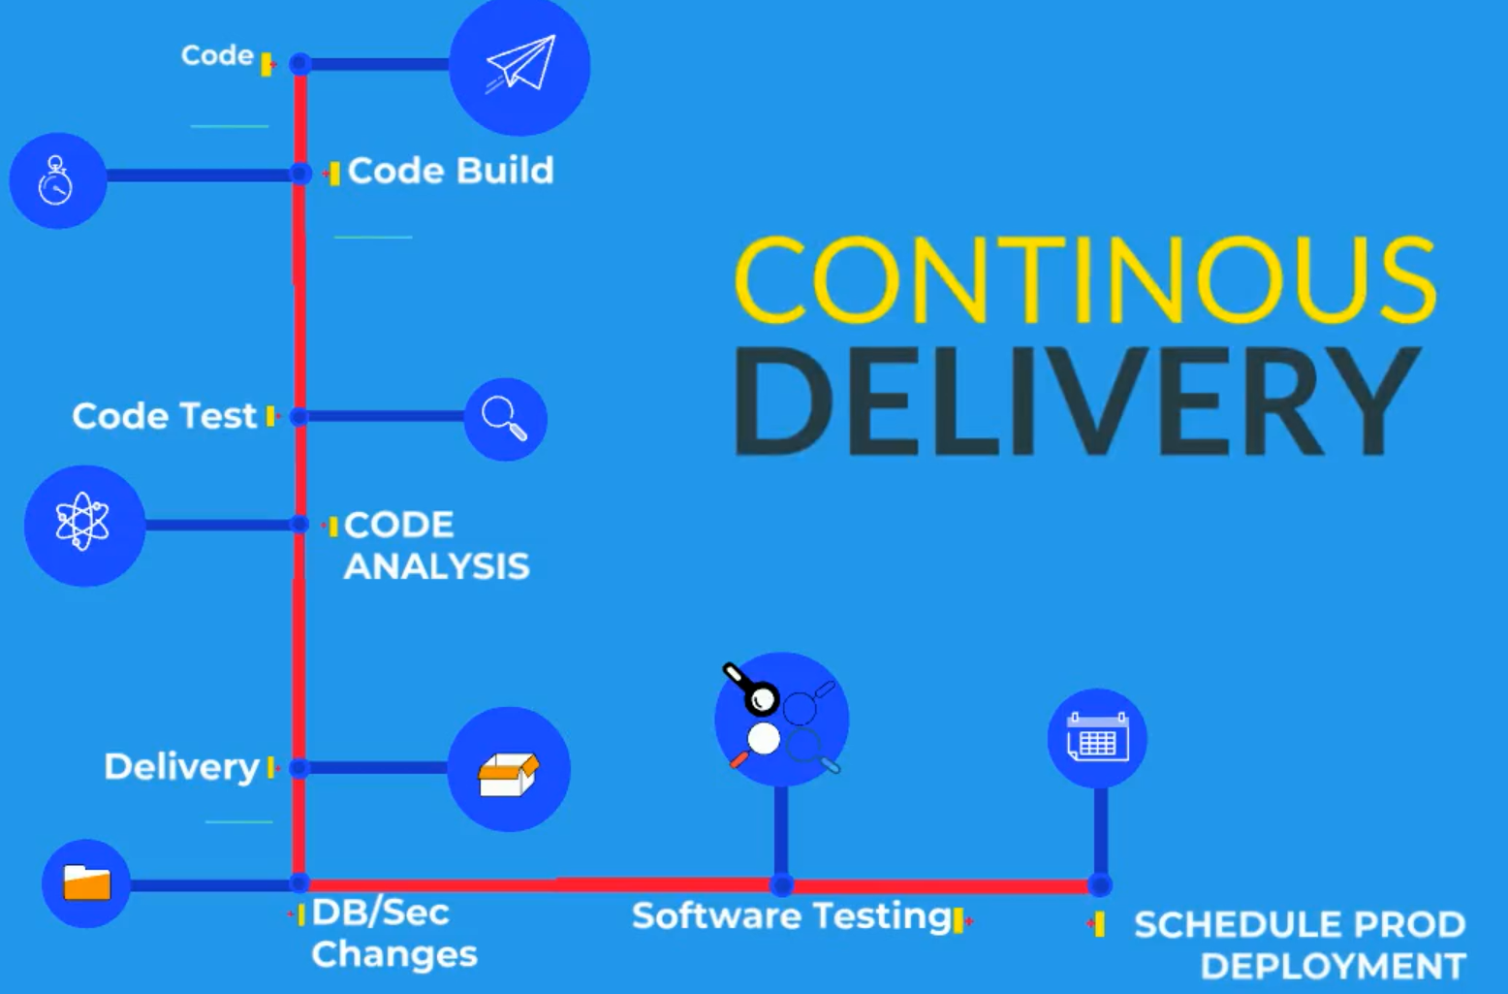

**To install chocolatey: window,mac**

<https://chocolatey.org/install>

1.paste and check policy: **Get-ExecutionPolicy**

2. Paste Set-ExecutionPolicy Bypass -Scope Process -Force; [System.Net.ServicePointManager]::SecurityProtocol = [System.Net.ServicePointManager]::SecurityProtocol -bor 3072; iex ((New-Object System.Net.WebClient).DownloadString('https://community.chocolatey.org/install.ps1'))

In window powershell

3. install virtulabox

**Mac: homebrew**

1.copy command and run it in terminal

2.virtual box

#### ****Tools Prerequisites for Ubuntu 20****

**Install Virtualbox**

$ sudo apt update

$ sudo apt install virtualbox

**Install Vagrant**

$ curl -O <https://releases.hashicorp.com/vagrant/2.2.9/vagrant_2.2.9_x86_64.deb>

$ sudo apt install ./vagrant_2.2.9_x86_64.deb

**Install Git**

$ apt install git

**Install jdk8**

$ sudo apt-get install openjdk-8-jdk

**Install Maven**

$ sudo apt-get install maven

**Install awscli**

$ sudo apt-get install awscli

**Install Intellij community**

$ sudo snap install intellij-idea-community --classic

**Install Sublime Text**

* $ sudo apt update
* $ sudo apt install dirmngr gnupg apt-transport-https ca-certificates software-properties-common
* $ curl -fsSL https://download.sublimetext.com/sublimehq-pub.gpg | sudo apt-key add -
* $ sudo add-apt-repository "deb https://download.sublimetext.com/ apt/stable/"
* $ sudo apt install sublime-text

**Signup**

1. GitHub
2. Domain purchase(godaddy)
3. Dockerhub
4. Sonarcloud

**Virtualization:**

* VMware: Allows one computer to run multiple OS
* Partition physical resource in virtual resource
* Virtual machine runs in isolated Env
* Each virtual machine needs its own OS
* Server virtualization is the most common virtualization

**Terminologies:**

1. Host OS: OS of the physical machine, like ur laptop or desktop
2. Gest OS: OS of the virtual machine
3. VM: Short form of virtual machine
4. Snapshot: Is we take the backup of virtual machine
5. Hypervisor: Is a tool or software that create virtual machine, it enables VM
6. Two of Hypervisor:

**Type 1:**

Bare Metal

Runs as a base os on ur physical machine

Used only in production

Ex: VMware esxi, Xen Hypervisor

**Type2:**

Runs as a software

Install on any computer

Learn and test

Oracle vm

Type1 hypervisor can be Cluster together . we can distribute vm on the cluster hypervisor. If one VM goes down the other one runs.

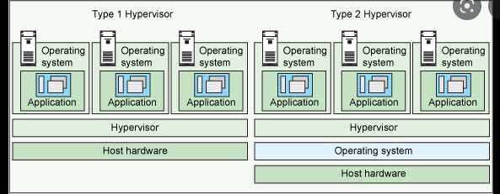

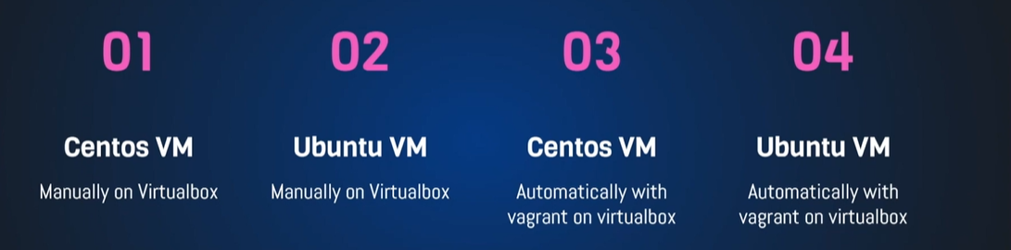

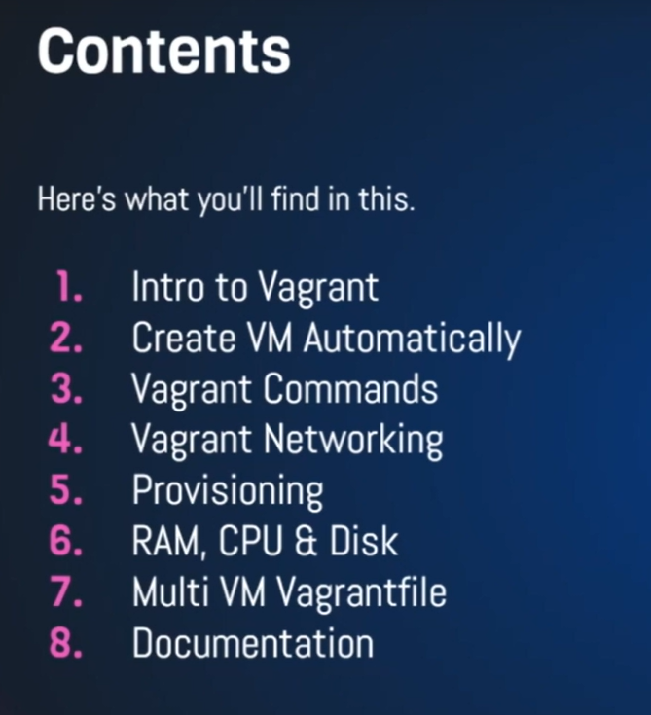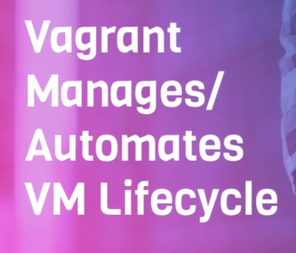

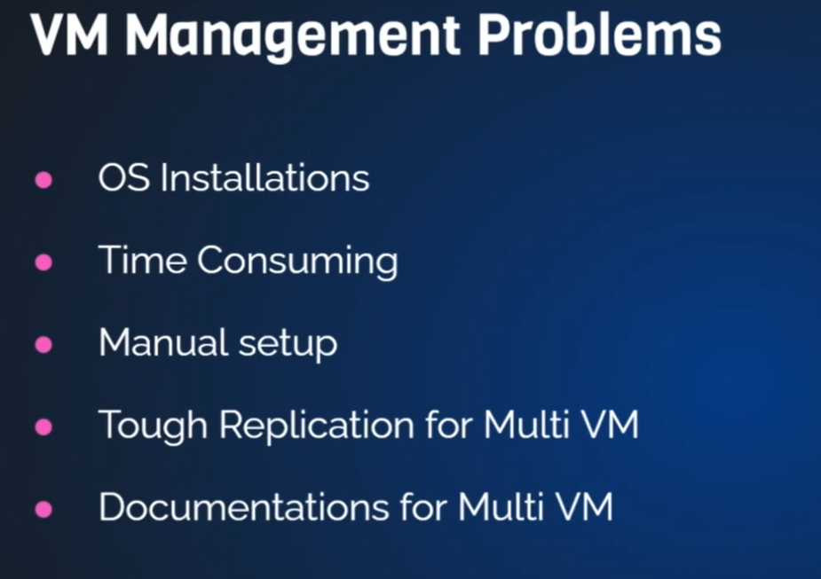

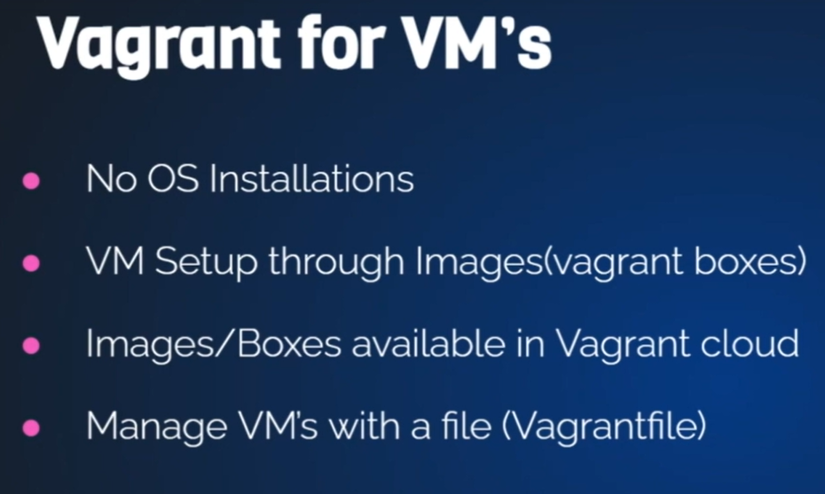

* To create Vagrant file: vagrant init name
* Vagrant up
* Vagrant ssh for login
* Vagrant destroy: delete the vm
* Vagrant reload : to reboot
* History: to see the previous used command
* Vagrant stop: vagrant halt

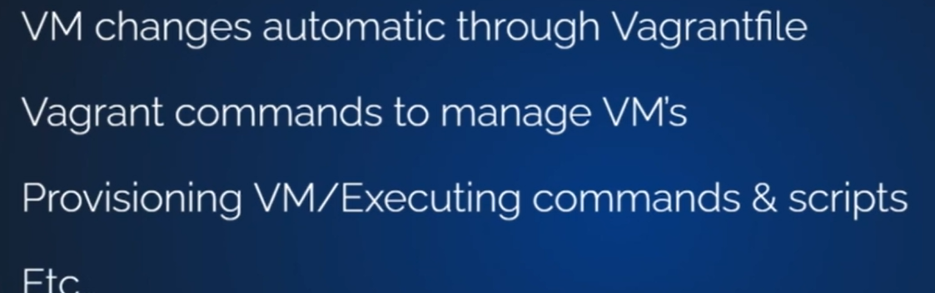

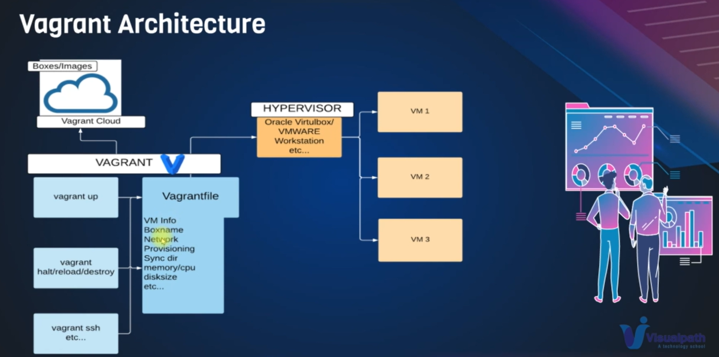

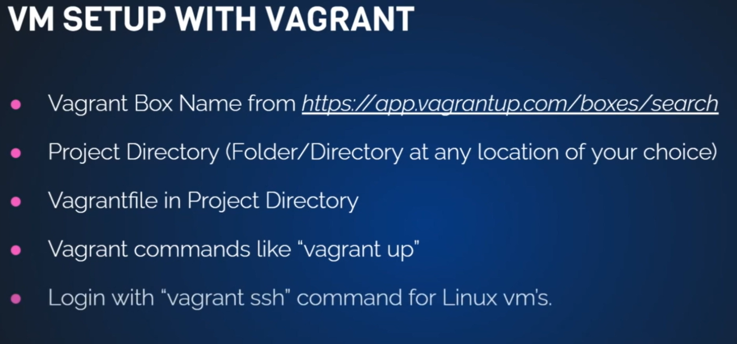

**Linux:**

1. Command
2. Files
3. Software’s
4. servers

Open sources:

**Linux principles:**

* Everything is a file(include hardware)
* Small single purpose program
* Ability to chain program together for complex operations
* Avoid captive user interface
* Configuration data stored in text file
* Popular Linux distros:

**List of Linux distribution:**

RPM extension(.rpm) and Debian (.deb)

**Some Important Directories:**

* Home Directories: /root,/home/username: /root is for administrator user and /home/username is normal user.
* User Executable command are commands that we run as ls, cat ,pwd these command will be located in /bin or, /usr/bin or, /usr/local/bin, these command will be executed by normal user.
* System Executables: /sbin, /usr/sbin, /usr/local/sbin , these command are executed by root user for installing the software.
* Other mountpoints: when we connect external harddisk it is mount in the /media, /mnt.
* Configuration: confirmation data will store in the /etc command like network confirmation, server confirmation, user confirmation.
* Temporary files: any temporary file can be add to /tmp command, but when u reboot it will deleted.
* Kernels and Bootloader are located in the /boot.
* Server data: the server information will store in the /var , /srv like website and mysql.
* System Information: will store in the /lib, /usr/lib, /usr/local/lib.
* Shared libraries : /lib , /usr/lib, /usr/local/lib

**Commands:**

* Promat:[vargant@localhost ~]$: for normal user.
* Promat:[root@localhost ~] #: for root user.
* ~ : is home directory
* whoami: name of the directory
* pwd: present working directory
* ls : Listing of files
* cat /etc/os-release : print file that is store in etc/os-release command
* change form normal to root: sudo -i

**Directory structure:**

Cd /: forward slash is the root directory

**Basic file base command:**

* To home directory :cd ~
* Coping one directory to other directory : cp -r directory1 to directory2
* Syntax: command options arguments
* Move command: mv can directly move from one directory to another . and also can rename using mv command
* *:means everything
* rm :remove command of file. rm -r : remove the directory.
* rm -rf * remove all file and directory in that directory
* history :displaying all command previous used

**VIM:**

* yy: copy line in vim
* p: paste below
* P: paste above
* dd: delete, 4dd :delete 4lines
* u: undo
* for search click /and type the name to search
* linking file: if the file is large and have to make small, then use the: ln -s file_location new_name
* cat new_name: display the file content.
* If u what to remove means type: unlink new_name.
* ls -lt: sort according to the present time
* ls -ltr: sort according to the previous to first

**Filtering command:**

* If we want to ignore casesensitive use -I : grep -I word_name file_name
* To search the word: grep word_name file_name
* To display from all files the word use : grep -i firewall *
* If u what to get into directory also means uses the: grep -iR firewall *
* If u what to search something that is which file it is located in directory means then use: grep -R word_name /etc/*
* If u what to do not show anything in the file that , what name ur search: grep -vi word_name file_name
* less file_name: used for reading the all word in the file and it will display all content in the file.
* more file_name: same as less
* head file_name: used for display the first coming lines
* tail file_name :oppoisite of head
* tail -f file_name: used for log file. also used
* log files are located in the /var/log/
* command used to separate the groups are: cut -d: -f1 /etc/passwd
* command that is use to search and filtering regular expression and all delimeter : awk -F’:’ ‘{print $1}’ /etc/passwd
* In vim to search and replace text is -> :%s/searchingword/replaceword
* In vim to search and replace everywhere Is -> :%s/searchingword/replaceword/g
* In vim to search and replace everywhere with nothing Is -> :%s/searchingword//g
* sed command to change and replace the word: sed ‘s/ searchingword/replaceword/g’ filename.txt
* sed command to change and replace the everytime: sed -i ‘s/searchingword/replaceword/g’ filename.txt